Name and Std ID: Riley Lawson rjlawson Lab Section: 6

Date: 10/22/2020

**PRELAB:**

**Q1.** Read section 2.2 and write the Verilog code for a 4-to-1 multiplexer.

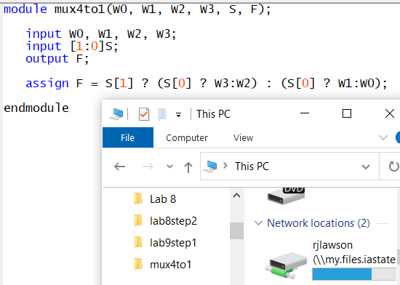

**Q2.** Design a 4-bit shifter as described in Section 3.1 of the lab description. Sketch the block diagram for your design showing the multiplexers, the inputs, outputs and the selectors to each multiplexer.

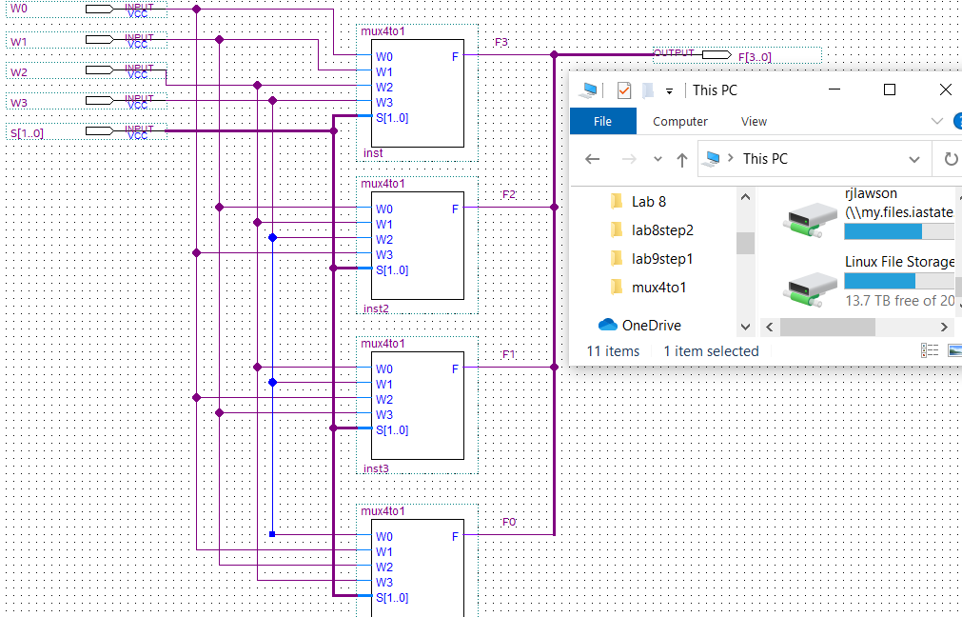

**Q3.** Refer to Section 3.1 of the lab description and complete the following table before you come to the lab:

|  |  |  |  |  |  |  |  |  |  |  |  |  |
| --- | --- | --- | --- | --- | --- | --- | --- | --- | --- | --- | --- | --- |
| **X3** | **X2** | **X1** | **X0** | **X-1** | **X-2** | **X-3** | **S1** | **S0** | **F3** | **F2** | **F1** | **F0** |
| 1 | 0 | 0 | 1 | 1 | 1 | 0 | 0 | 1 | 0 | 0 | 1 | 1 |
| 1 | 1 | 1 | 0 | 0 | 0 | 0 | 1 | 1 | 0 | 0 | 0 | 0 |
| 1 | 1 | 1 | 0 | 0 | 1 | 1 | 0 | 0 | 1 | 1 | 1 | 0 |
| 1 | 1 | 0 | 1 | 0 | 1 | 0 | 1 | 0 | 0 | 1 | 0 | 1 |
| 1 | 0 | 1 | 1 | 0 | 1 | 1 | 0 | 1 | 0 | 1 | 1 | 0 |



**LAB:**

**2.1**  Hardware results demonstrate a good circuit.

Screenshots:

**2.2**  Hardware results demonstrate correct code.

Screenshots:

**3.1**  Hardware results demonstrate correct code.

Screenshots: